Christen Clark liri.js file working for each question: concert-this, spotify-this-song, movie-this and do-what-it-says.

Screen shot of concert-this “rolling stones” shows Venue, Location and Event Date for several locations. I see 13 locations. The limit set is 20.

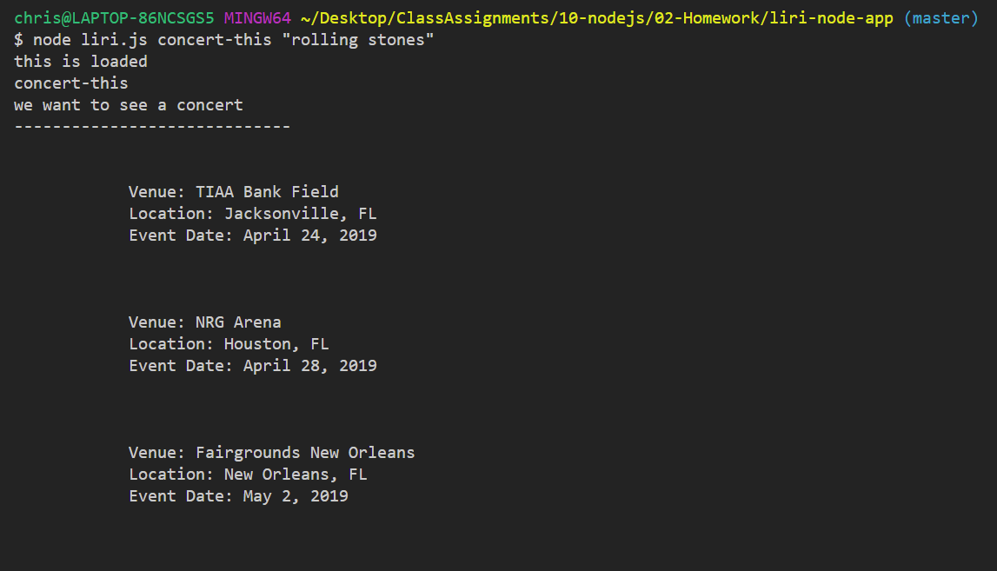

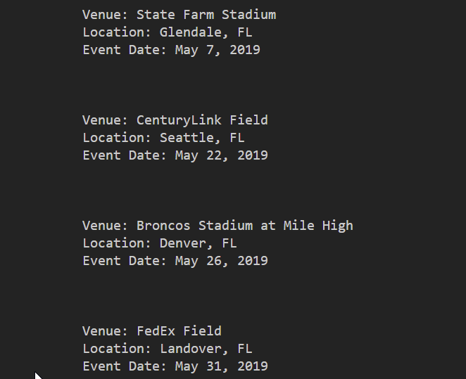

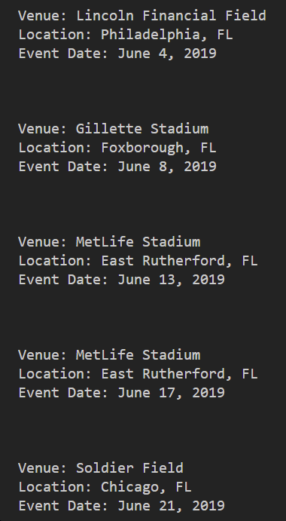

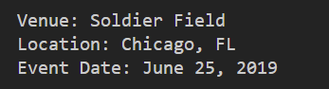

This is a spotify-this-song of the song speak life by TobyMac

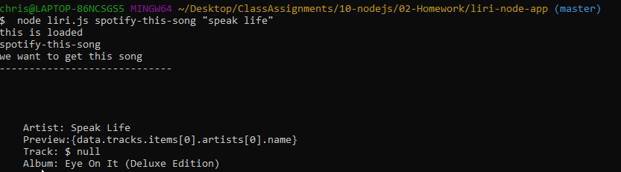

This is the movie-this of the movie Big

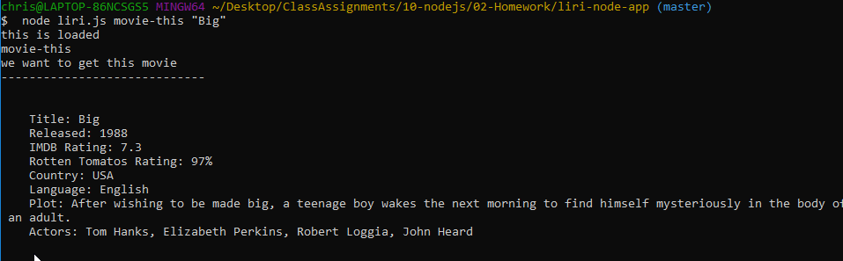

This is the do-what-it-says command

